**User Diagrams**

Main System page

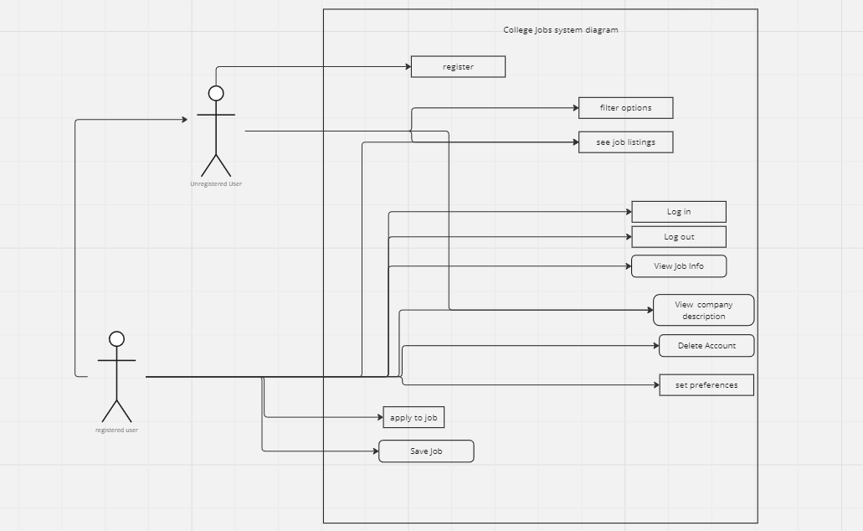

Extending Resources

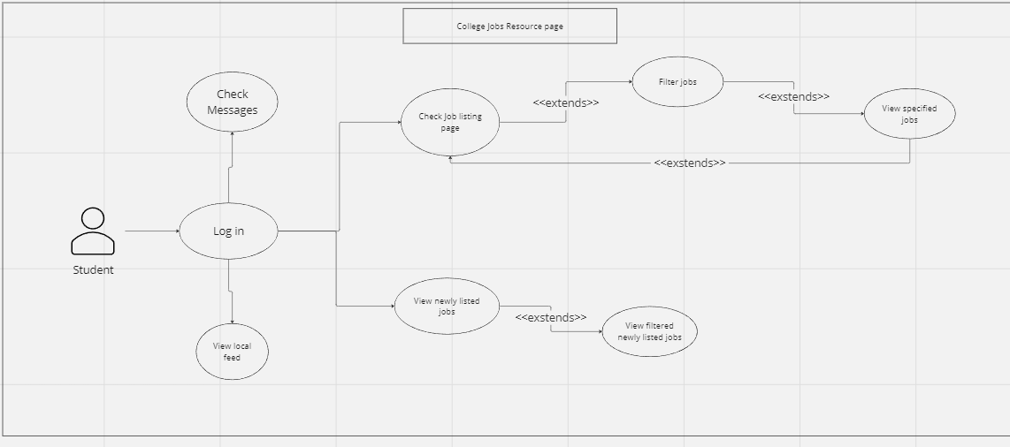

**Use Case Descriptions**

| **Name:** | Bookmarking/saving a job listing | | |
| --- | --- | --- | --- |
| **ID:** | 10 | | |
| **Description** | As a college student, I would like to be able to save a job for later if I find one that I like but want to continue to look for other jobs so I can easily go back and find it later. | | |
| **Precondition:** | * User is logged in | | |
| **Success Postconditions:** | * Job listing is saved to bookmarks for viewing later * User is returned to the feed view | | |
| **USER STEPS:**   1. Clicks on a relevant job listing 2. Clicks the “Save” or “Bookmark” button | | **SYSTEM RESPONSE:**   1. Shows information about the job listing, and displays a “Save” or “Bookmark” button 2. Displays a notification indicating it has been saved 3. Returns user to feed or search view | |

| **Name:** | Add Company Description to Account |
| --- | --- |
| **ID:** | 11 |
| **Description**: | The company users shall be able to add a company description for the student users to view. |
| **Success Postcondition**: | A company description is added. |

| **USER STEPS**:  1. Company users click the “Create Company Description” button.  3. Types in company description.  4. Click the “Submit” button.  6. Clicks confirm.  8. Student users click on the company profile.  10. Student users are able to view company descriptions. | **SYSTEM RESPONSE**:  2. Pop up to enter the company description.  4. Verifies input is valid.  5. Displays confirmation.  7. Adds description to company profile.  9. Displays that company’s profile. |
| --- | --- |

| **Name/Title:** | Apply for Job |
| --- | --- |
| **ID:** | 15 |
| **Description**: | As a student who is looking for a job, I want to be able to apply for the job that I am looking for. |
| **Precondition**: | The user has a website open |
| **Success Postcondition**: | The website brings the application for the job that you are applying to. |

| **USER STEPS**:  1. Click on the search bar and enter the job that you are looking for.  3. Click on a specific job.  5. Click on the link to the application. | **SYSTEM RESPONSE**:  2. Shows a list of all the jobs that fit the search description.  4. The screen displays information about the job and the link to the application.  6. Bring you to the page to fill out the job application. |
| --- | --- |

| **Name/Title:** | View All Company Listings |
| --- | --- |
| **ID:** | 114 |
| **Description**: | As a Student, I want to be able to click on a specific company and be able to see all of the jobs that they have posted and also see a description of what the company does. |
| **System Under Design:** | College Jobs |
| **Primary Actor**: | Registered User |
| **Participants**: | Registered users |
| **Goal**: | See all of a company’s listings. |
| **Related Use Cases**: | Employer based |
| **Invariant**: | User needs to be logged out |
| **Precondition**: | User must be logged in |
| **Success Postcondition**: | Pops up all of a company’s listings. |

| **USER STEPS**:  1. User opens search menu  3. User picks a company.  5. User picks all company listings. | **SYSTEM RESPONSE**:  2. System shows search menu  4.System shows the company page  6.System returns all of company’s listings. |
| --- | --- |

| **Name:** | Filter jobs |
| --- | --- |
| **ID:** | 14 |
| **Description**: | As a user, I want to be able to use a filter to search for jobs that are more suitable for me and match the requirements that I am looking for. |
| **Precondition:** | User is viewing job feed or job search page |
| **Success Postcondition**: | App shows only jobs that match the filter conditions |

| **USER STEPS**:  1. Click on “Filter” button to the left of job list  3. Selects one or more filter conditions  4. Clicks “Submit” | **SYSTEM RESPONSE**:  2. Shows filter sidebar with sliders for min/max pay and date posted, and drop downs for job category, location radius, and skills required  4. Clicked filter conditions are highlighted  5. System checks each job listing against filters   1. Shows only jobs that match the filter conditions or 2. Displays “No jobs match filters” |
| --- | --- |

| **Name/Title:** | Registering |
| --- | --- |
| **ID:** | 101 |
| **Description**: | As a Student or Company, I want to be able to register for a new account using an email. |
| **System Under Design:** | MajorHelp |
| **Primary Actor**: | Unregistered User |
| **Participants**: | students |
| **Goal**: | To be able to register to use the site |
| **Related Use Cases**: | Log in, sign up |
| **Invariant**: | User must be registered |
| **Precondition**: | User can not have an account |
| **Success Postcondition**: | Registers the user bring them to the profile page |

| **USER STEPS**:  1. User clicks register  3. Fills out information and clicks submit  … | **SYSTEM RESPONSE**:  2. System brings them to sign up page  4.System brings them to their profile  … |
| --- | --- |

| **Name/Title:** | Job Feed |
| --- | --- |
| **ID:** | 107 |
| **Description**: | As a student I want to be able see a feed of jobs on the home screen that the site is recommending to me so that I might be able to find jobs that I might not have thought to search for. |
| **System Under Design:** | College Jobs |
| **Primary Actor**: | Registered User |
| **Participants**: | Unregistered user, employers |
| **Goal**: | To have an active feed of current job offers. |
| **Related Use Cases**: | Filtering jobs |
| **Invariant**: | User must be logged in |
| **Precondition**: | User must click on job feed |
| **Success Postcondition**: | Brings the user to the active job feed. |

| **USER STEPS**:  1. User clicks on job feed.  … | **SYSTEM RESPONSE**:  2. System pops up the job feed  … |
| --- | --- |

| **Name/Title:** | Freelance Job Offerings |
| --- | --- |
| **ID:** | 112 |
| **Description**: | As a college student, I want to be able to find a freelance job on the website so that I can still work even if I do not have the time for a full-time or part-time job. |
| **System Under Design:** | College Jobs |
| **Primary Actor**: | Registered User |
| **Participants**: | Employers |
| **Goal**: | The option to apply for freelance work. |
| **Related Use Cases**: | Job Listings |
| **Invariant**: | User must work full time |
| **Precondition**: | Freelance job offerings |
| **Success Postcondition**: | Can apply to do freelance work |

| **USER STEPS**:  1. User goes to search bar  3. User searches “Freelance”  5. User applies to freelance job  … | **SYSTEM RESPONSE**:  2. System search bar indicated  4.System filters for freelance jobs  6.System pops up successful apply  … |
| --- | --- |

| **Name/Title:** | Job for Credits |
| --- | --- |
| **ID:** | 115 |
| **Description**: | As a college student, I want to be able to find a job that could qualify me to get college credits toward my degree. |
| **System Under Design:** | College Jobs |
| **Primary Actor**: | Registered User |
| **Participants**: | Employers, colleges |
| **Goal**: | The student can work and get a college credit at the same time |
| **Related Use Cases**: | Job listings, job filtering |
| **Invariant**: | User must be logged out |
| **Precondition**: | Must be a registered user in college |
| **Success Postcondition**: | Can apply for jobs that will give a college credit |

| **USER STEPS**:  1. User filters searches  3.User Applies to one with credits  … | **SYSTEM RESPONSE**:  2. System filters for the specified jobs  4.System gives a successful apply  … |
| --- | --- |

| **Name/Title:** | Retrieve Listing Updates |
| --- | --- |
| **ID:** | 12 |
| **Description**: | As a student I would like to receive listing updates as they are edited from the employer.. |
| **System Under Design:** | College Jobs |
| **Primary Actor**: | Student |
| **Participants**: | Students |
| **Goal**: | To be able to receive updated listings from employers. |
| **Related Use Cases**: | Job feed, saving job listing. |
| **Invariant**: | User must be logged out |
| **Precondition**: | Must be a registered user. |
| **Success Postcondition**: | Able to view an updated listing from the employer. |

| **USER STEPS**:  1. User clicks on the job listing.  … | **SYSTEM RESPONSE**:  2. System checks for the latest version of job listing.  3. System displays updated job listing if changed.  … |
| --- | --- |

| **Name/Title:** | Set job preferences. |
| --- | --- |
| **ID:** | 117 |
| **Description**: | As a student I would like to set job preferences so the system will give me better suggestions. |
| **System Under Design:** | College Jobs |
| **Primary Actor**: | Student |
| **Participants**: | Student |
| **Goal**: | To receive job listings based on job preferences. |
| **Related Use Cases**: | Job feed |
| **Invariant**: | User must be logged out |
| **Precondition**: | Must be a registered user. |
| **Success Postcondition**: | Job listings on job feed will tailor towards job preferences. |

| **USER STEPS**:  1. User clicks on set job preferences.  3. User selects which options to set for job preferences.  … | **SYSTEM RESPONSE**:  2. System returns options for the user to select.  4. System sets selected job preferences for the user.  5. System displays job listings on job feed for users based on the preferences.  … |
| --- | --- |

| **Name/Title:** | Add Skills to Profile |
| --- | --- |
| **ID:** | 119 |
| **Description**: | As a student I would like to be able to add skills to my profile so when I apply it will auto fill into the application. |
| **System Under Design:** | College Jobs |
| **Primary Actor**: | Student |
| **Participants**: | Student |
| **Goal**: | To add skills to a user’s profile so they auto fill when a user uses “easy apply.” |
| **Related Use Cases**: | Apply for job. |
| **Invariant**: | User must be logged out |
| **Precondition**: | Must be a registered user. |
| **Success Postcondition**: | Skills are auto-filled into an “easy application.” |

| **USER STEPS**:  1. User clicks on set skills.  3. User enters skills they wish to have listed on their profile.  … | **SYSTEM RESPONSE**:  2. System pops up an input box where users can enter their skills..  4. System sets skills for the user.  5. System autofills skills into an application when the user uses “easy apply.”  … |
| --- | --- |